COS225 Assignment #9 Name _____________________________
Due: Friday 4/20/18
Late: Friday 4/27/18

Part I. (20 pts.)

#1. (12) Use the tree shown below to answer the questions.

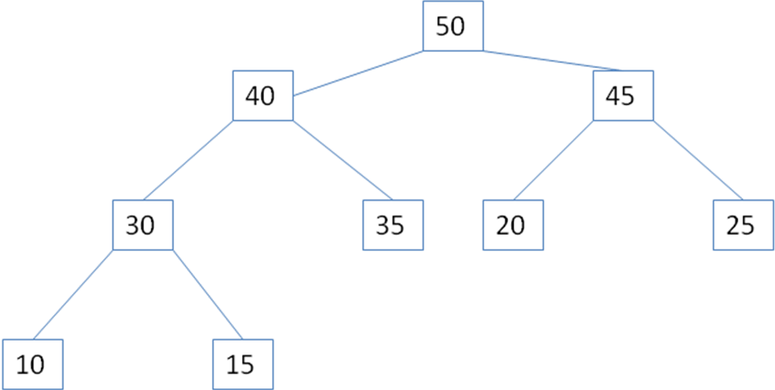

d. Write the nodes in the order accessed using a postorder traversal:

e. Write the nodes in the order accessed using a preorder traversal:

f. Write the nodes in the order accessed using an inorder traversal:

#2. (8) Use the Heap class presented in lecture.

a. Draw the tree model and show the values in the array after inserting numbers in the following order:

10 40 70 80 30 50 90

b. Draw the tree model and show the values in the array after the first removal.

Part II (80 pts.) The Morse code is used to encode messages where each letter is coded as a unique series of dashes and dots. This problem will practice building a binary tree to store the alphabet letters. Code will use the TreeNode.java class built in lecture. The text file below lists each letter followed by its code.

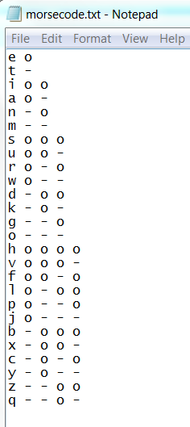

Store each letter of the alphabet in a binary tree. The root node stores no letter. Travel to the left represents a dot and travel to the right represents a dash. Build the tree using the Morse code to travel left or right and then insert the letter.

a. Initially the tree has a root node with no element.

b. Read the first line of the text file: e o Letter e is represented by a single dot. Travel begins from the root. Dot means travel left. There is no left child encountered so make a node and insert letter e.

e

c. Read the next line of the text file: t - Letter t is represented by a single dash. Travel begins from the root. Dash means travel right. There is no right child so make a node and insert letter t.

e
t

d. Read the next line of the text file: i o o Letter i is represented by a two dots. Dot means travel left. The first left goes to node e. There is no left child of e so make a node and insert letter i.

e
t

i

e. Repeat this process until all letters have been processed from the file and inserted into the tree.

2. Use a container to store the code for each letter. Store the code for the letter at the index using its ASCII code to determine position. The ASCII sequence for 'a' begins at code 97.

Ex. Morse code for 'a' is stored in index 0, Morse code for 'b' is stored in index 1, etc.

o - | - o o o
0 1 2 3 4 5 6 7 8 9 …

3. After the two data structures are filled, run an interactive program where the user enters an English message using words in lower case with no punctuation, report the Morse code equivalent using the array with character | to separate codes, and then decode the Morse code back to English using the tree. Report the preorder traversal of the tree. Turn in the following test cases to ensure all letters work.

